

**CITY UNIVERSITY**

**LAB Assignment-01**

**Assignment Name: System Analysis & Design(Lab)**

**Course Code: CSE-326**

**Course Title: System Analysis & Design**

**Submitted To: Richard Philip**

**Senior Lecturer, Department of CSE**

**City University, Bangladesh**

**Submitted By:**

|  |
| --- |
| **ID : 171442624**  **Name : Mustafizur Rahman Khan**  **Program : CSE(Eve)**  **Batch : 44th** |

**DATE OF ASSIGNED : 12-06-2019**

**Class diagram with address class and make aggregations on customer and address class:**

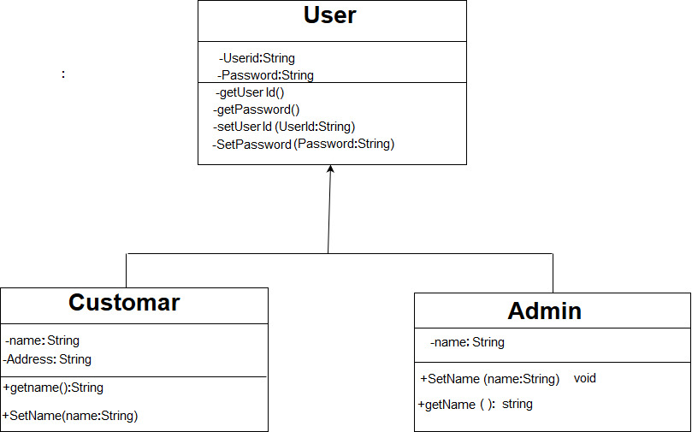

**Class diagrams are widely used to describe the types of objects in a system and their relationships. Class diagrams model class structure and contents using design elements such as classes, packages and objects. Class diagrams describe three different perspectives when designing a system, conceptual, specification, and implementation. These perspectives become evident as the diagram is created** **and help solidify the design**